**Jess Cherayil (jcherayi) + Sheree Liu (sliu4) take on PHASE 1 of Beyoncé Lyrics Quiz:**

**Summary:**

Our GUI is a 10 question Buzzfeed-esque Beyoncé lyrics quiz with levels Easy, Medium, and Hard. We will provide the user with a random lyric from a Beyoncé song, as well as a picture of Beyoncé. Lyrics will get more obscure or shorter as difficulty level increases. Each question will generate a random picture of Beyoncé, because who doesn’t like Beyoncé? After 10 questions have been answered, the quiz will be over and a number of correct answers will be displayed! This was somewhat modeled after the Trivia Game from PSet 9.

**Pics or it didn’t happen:**

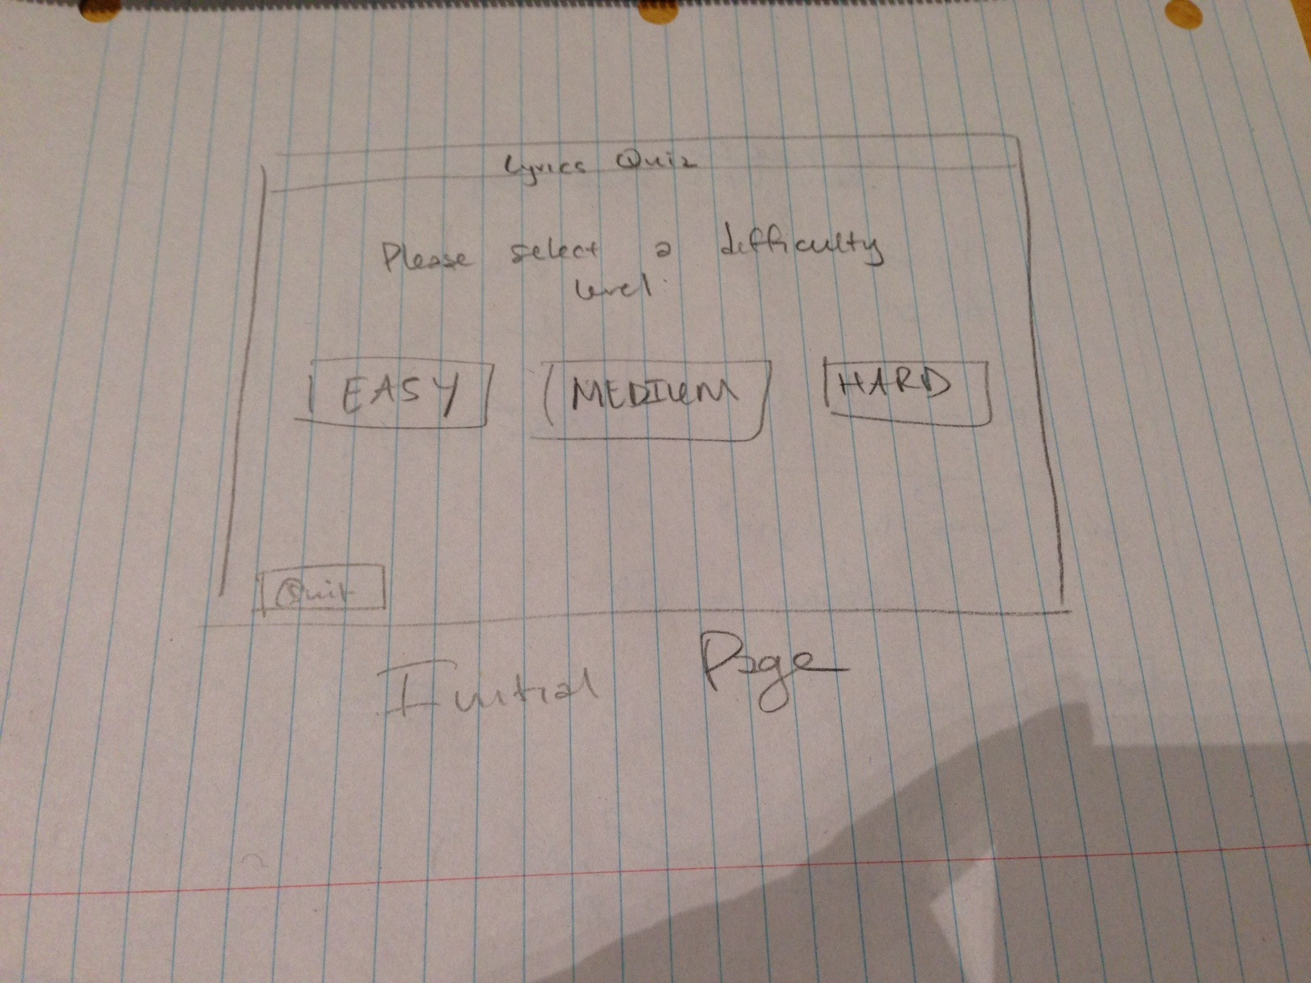

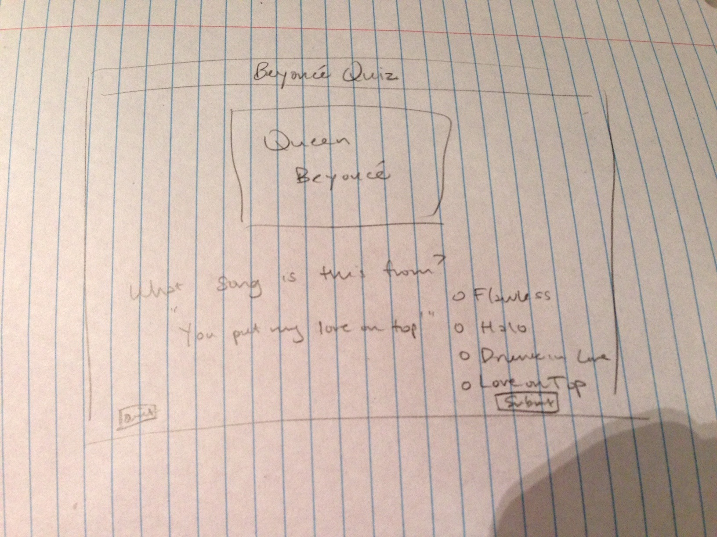

**Classes:**

Our first class (Difficulty) will determine what happens when a certain difficulty level is selected. The second class (QuestionsAndAnswers) will read from three different text files (easy, medium, and hard) and will get a random lyric, song options, and picture. The third class (LyricQuizApp) will work to actually set up the GUI by creating the necessary widgets and displays.

**Actions:**

1. Difficulty class:

* __init__(self)
* selectDifficulty(self)

2. QuestionsAndAnswers class:

* __init__(self)
* getRandomQAndANumber(self)
* getLyric(self, number)
* getSong(self, number)
* getPicture(self, number)

3. LyricQuizApp class:

* __init__(self)
* createWidgets(self)
* setLyric(self)
* setSong(self)
* setPicture(self)
* onEasyButtonClick(self)
* onMediumButtonClick(self)
* onHardButtonClick(self)
* onSubmitButtonClick(self)
* onQuitButtonClick(self)